Crowdfunding Campaign Outreach Template

This template aims to help you plan your campaign launch. Remember, uploading your project is the easy part; managing a successful outreach campaign is much more difficult, and usually takes 2 months of preparation! An estimated 80% of funds are raised in the first and last 3 days of a campaign-- so set your launch date, and be sure to push to the end!

Email draft:
Send to Friends and family asking for support to spread the word! See Indigogo’s 4 Steps to Email Outreach Success and Gaza Sky Geeks’s example.

The Onion Method starts with your closest supporters at the core, and then builds layers:

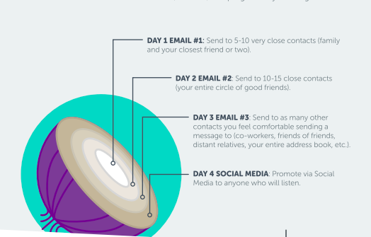

Key Message:
Develop key messages that others can easily copy/paste to share with their network. Be sure to include a template for emails, facebook, and twitter. Include visuals that can be easily shared.

Email to key supporters:

Dear [recipient’s preferred name],

I hope that you’re doing well! [Insert a relevant or personal anecdote].

As you may have heard, I’m raising money for our crowdfunding campaign [summary on the campiang].

You can make a donation [or buy the product] on my crowdfunding campaign page by clicking (here). Thank you in advance for your support. Please let me know if you have any questions about my campaign, my goal, or [your cause, project, event, etc.].

We are aiming to reach 30% of the goal in the next two weeks before the official campaign launch on social media. Be one of the first supporters!

Sincerely/Much love/Best/etc.,
[NAME

Social Media Management:
What does it take to make a campaign go viral? The experts agree that it is truly up to chance, but it’s still worth trying!
- Hashtags:
- Facebook Event:
- Facebook Page:

Facebook Groups/ Pages | Social Media Influencers | Mailing Lists
Key Supporters:

Mass Emails:

Social Media Posting Scheduling

You can use this Social Media Schedule Template

Offline Fundraiser:
We strongly encourage campaigns to run an offline fundraiser that will allow supporters to provide offline donations, while also helping to create a buzz in the middle of your campaign! Don’t forget to create a Facebook event with the same visuals.

Media:
Develop a press release in both English and Arabic that can be circulated with media contacts. See Krowdster’s Crowdfunding Press Release Template.

Media Source | Contact | Published?

Showing Gratitude
Once a supporter makes a contribution to your campaign, make sure to send the Thank you email. You can customize the template below, or make a Thank you design that you can send. Also, ask them to share it with their networks.

Template:

Dear [NAME],

Thank you for your generous support! Your contribution is really appreciated by our team and helped us get closer to our goal.

If you have a few more minutes, we would greatly appreciate it if you could share this campaign with 3 people you think would also be interested in supporting our work. Also remember, simply sharing on social media can on average add another $37 to our campaign.

Thank you again for your support and being a part of this impact. If you have questions or feedback at any time, our team would love to hear from you.

OPTIONAL TO ADD
Facebook [add post link on Facebook]
LinkedIn [add post link on LinkedIn]
Email [Add sample email]

NOTE: If the campaign is selling a product, you should send information about how the supporter will receive the product and when to expect it.

Additional Resources:

- StartSomeGood 2019 Outreach Kit (HIGHLY RECOMMENDED TO READ)
- 9 Steps to a Successful Crowdfunding Campaign (BuildPalestine)
- The Crowdfunding Bible
- How to Run a Successful Crowdfunding Campaign: A Step-by- Step Guide by Gaza Sky Geeks
- Crowdfunding for Nonprofits (Classy)
- Indiegogo Prep Calendar
- Infographic: 6 Steps to a Successful Fundraiser

Best of luck! We are here to support you along this journey, so please feel free to reach out anytime along the way!

